**CSE3002 Internet and Web Programming**

**Lab Assessment 6**

**XML Validation**

Submitted by

**Patel Vishva Pravinkumar (17BCE0940)**

November 1, 2019

**Problem Description**

Create an XML document with the following

Root Element: real-estate

sub-elements for real-estate: agencies, owners, properties and flats

sub-elements contain the attributes (Specify appropriate attributes of your own with datatypes)

Agency = name, e-mail, phone

Owner = name

Property = name, description, number of flats, features, owner reference

Flat = name, description, features, property reference

* Ensure well-formedness, ensure its validity by checking with DTD and XML Schema
* Use XSL to apply the style with the HTML template for the elements: Owner & PropertyAddress only
* Use attributes for references, otherwise elements
* Use only CDATA and #PCDATA for content and values

**Document Formation**

|  |
| --- |
| 1. **Code**    1. XML File (ast6.xml)    2. DTD File (ast6.dtd)    3. XML Schema File (ast6.xsd)    4. XSL Transformation (to HTML) file (ast6.xsl) 2. **Output Screenshots**    1. XML file view on Internet Explorer 3. **Well Formedness of ast6.xml - screenshots**    1. notepad++    2. w3school online validator 4. **Validation of ast6.xml - screenshots**    1. XML DTD Validation    2. XML Schema Validation |

**XML File (ast6.xml)**

<?xml version=**"1.0"** encoding=**"UTF-8”**?>

<?xml-stylesheet type=**"text/xsl"** href=**"ast6.xsl"**?>

<!DOCTYPE note SYSTEM "ast6.dtd” >

<!-- root element -->

<real-estate>

<!-- agencies is a child element of root-->

<agencies>

<agency>

<name>**Patel Builders**</name>

<email>**vishvapatel652@gmail.com**</email>

<phone>**9003362230**</phone>

</agency>

<agency>

<name>**Vishva Developers**</name>

<email>**vishvap@gmail.com**</email>

<phone>**9106848042**</phone>

</agency>

</agencies>

<!-- owners is a child element of root -->

<owners>

<owner>

<name>**Vishva Patel**</name>

</owner>

<owner>

<name>**S Rama**</name>

</owner>

<owner>

<name>**Anand Vishva**</name>

</owner>

</owners>

<!-- properties is a child element of root -->

<properties>

<property owner=**"Vishva Patel"**><!-- owner reference for property -->

<name>**Aakash Group**</name><!-- sub-child elements for properties element -->

<desc>**Wonderful place in center of city and near VIP road**</desc>

<noOfFlat>**16**</noOfFlat>

<features>

<feature>**3 Automatic Elevator**</feature>

<feature> **Garden**</feature>

<feature>**Swimming pool**</feature>

<feature>**Gym**</feature>

<feature>**24*7 security**</feature>

<feature>**Inter communication**</feature>

</features>

</property>

</properties>

<!-- flats is a child element of root -->

<flats>

<flat property=**"Akash Group"**><!-- reference to property for flat element -->

<name> **Akash East Point**</name>

<desc> **Amazing architecture with modern facilities**</desc>

<features>

<feature> **5 BHK**</feature>

<feature> **Centralized AC**</feature>

<feature> **4 bathrooms**</feature>

<feature> **Green environment**</feature>

<feature> **happy home**</feature>

</features>

</flat>

</flats>

</real-estate>

**DTD File (ast6.dtd)**

<!ELEMENT real-estate (agencies, owners, properties, flats)>

<!ELEMENT agencies (agency*)>

<!ELEMENT owners (owner*)>

<!ELEMENT properties (property*)>

<!ELEMENT flats (flat*)>

<!ELEMENT agency (name, email, phone)>

<!ELEMENT owner (name)>

<!ELEMENT property (name, desc, noOfFlat, features?)>

<!ATTLIST property owner CDATA #REQUIRED>

<!ELEMENT flat (name, desc, features)>

<!ATTLIST flat property CDATA #REQUIRED>

<!ELEMENT name (#PCDATA)>

<!ELEMENT email (#PCDATA)>

<!ELEMENT phone (#PCDATA)>

<!ELEMENT noOfFlat (#PCDATA)>

<!ELEMENT desc (#PCDATA)>

<!ELEMENT features (feature+)>

<!ELEMENT feature (#PCDATA)>

**XML Schema File (ast6.xsd)**

<xs:schema attributeFormDefault=**"unqualified"** elementFormDefault=**"qualified"** xmlns:xs=**"http://www.w3.org/2001/XMLSchema"**>

<xs:element name=**"real-estate"**>

<xs:annotation>

<xs:documentation>**root element**</xs:documentation>

</xs:annotation>

<xs:complexType>

<xs:sequence>

<xs:element name=**"agencies"**>

<xs:annotation>

<xs:documentation>**agencies is a child element of root**</xs:documentation>

</xs:annotation>

<xs:complexType>

<xs:sequence>

<xs:element name=**"agency"** maxOccurs=**"unbounded"** minOccurs=**"0"**>

<xs:complexType>

<xs:sequence>

<xs:element type=**"xs:string"** name=**"name"**/>

<xs:element type=**"xs:string"** name=**"email"**/>

<xs:element type=**"xs:long"** name=**"phone"**/>

</xs:sequence>

</xs:complexType>

</xs:element>

</xs:sequence>

</xs:complexType>

</xs:element>

<xs:element name=**"owners"**>

<xs:annotation>

<xs:documentation>**owners is a child element of root**</xs:documentation>

</xs:annotation>

<xs:complexType>

<xs:sequence>

<xs:element name=**"owner"** maxOccurs=**"unbounded"** minOccurs=**"0"**>

<xs:complexType>

<xs:sequence>

<xs:element type=**"xs:string"** name=**"name"**/>

</xs:sequence>

</xs:complexType>

</xs:element>

</xs:sequence>

</xs:complexType>

</xs:element>

<xs:element name=**"properties"**>

<xs:annotation>

<xs:documentation>**properties is a child element of root**</xs:documentation>

</xs:annotation>

<xs:complexType>

<xs:sequence>

<xs:element name=**"property"**>

<xs:complexType>

<xs:sequence>

<xs:element type=**"xs:string"** name=**"name"**>

<xs:annotation>

<xs:documentation>**owner reference for property**</xs:documentation>

</xs:annotation>

</xs:element>

<xs:element type=**"xs:string"** name=**"desc"**>

<xs:annotation>

<xs:documentation>**sub-child elements for properties element**</xs:documentation>

</xs:annotation>

</xs:element>

<xs:element type=**"xs:byte"** name=**"noOfFlat"**/>

<xs:element name=**"features"**>

<xs:complexType>

<xs:sequence>

<xs:element type=**"xs:string"** name=**"feature"** maxOccurs=**"unbounded"** minOccurs=**"0"**/>

</xs:sequence>

</xs:complexType>

</xs:element>

</xs:sequence>

<xs:attribute type=**"xs:string"** name=**"owner"**/>

</xs:complexType>

</xs:element>

</xs:sequence>

</xs:complexType>

</xs:element>

<xs:element name=**"flats"**>

<xs:annotation>

<xs:documentation>**flats is a child element of root**</xs:documentation>

</xs:annotation>

<xs:complexType>

<xs:sequence>

<xs:element name=**"flat"**>

<xs:complexType>

<xs:sequence>

<xs:element type=**"xs:string"** name=**"name"**>

<xs:annotation>

<xs:documentation>**reference to property for flat element**</xs:documentation>

</xs:annotation>

</xs:element>

<xs:element type=**"xs:string"** name=**"desc"**/>

<xs:element name=**"features"**>

<xs:complexType>

<xs:sequence>

<xs:element type=**"xs:string"** name=**"feature"** maxOccurs=**"unbounded"** minOccurs=**"0"**/>

</xs:sequence>

</xs:complexType>

</xs:element>

</xs:sequence>

<xs:attribute type=**"xs:string"** name=**"property"**/>

</xs:complexType>

</xs:element>

</xs:sequence>

</xs:complexType>

</xs:element>

</xs:sequence>

</xs:complexType>

</xs:element>

</xs:schema>

**XSL Transformation (to HTML) file (ast6.xsl)**

<?xml version='1.0' encoding='UTF-8'?>

<xsl:stylesheet version="1.0" xmlns:xsl="http://www.w3.org/1999/XSL/Transform">

<xsl:template match="/">

<html>

<body>

<!-- agency elements display-->

<h1>Agency Details</h1>

<table border="2" bgcolor="yellow">

<tr>

<th>Agency Name</th>

<th>Email ID</th>

<th>Phone</th>

</tr>

<xsl:for-each select="real-estate/agencies/agency">

<tr>

<td><xsl:value-of select="name"/></td>

<td><xsl:value-of select="email"/></td>

<td><xsl:value-of select="phone"/></td>

</tr>

</xsl:for-each>

</table>

<!-- owner elements display-->

<h1>Owner Details</h1>

<table border="2" bgcolor="lightgreen">

<tr>

<th>Owner Name</th>

</tr>

<xsl:for-each select="real-estate/owners/owner">

<tr>

<td><xsl:value-of select="name"/></td>

</tr>

</xsl:for-each>

</table>

<!-- property elements display-->

<h1>Property Details</h1>

<table border="2" bgcolor="lightblue">

<tr>

<th>Property Name</th>

<th>Description</th>

<th>Number of Flats</th>

<th>Features Highlights</th>

</tr>

<xsl:for-each select="real-estate/properties/property">

<tr>

<td><xsl:value-of select="name"/></td>

<td><xsl:value-of select="desc"/></td>

<td><xsl:value-of select="noOfFlat"/></td>

<td><xsl:value-of select="features"/></td>

</tr>

</xsl:for-each>

</table>

<!-- flat info -->

<h1> Flat Details</h1>

<table border="2" bgcolor="pink">

<tr>

<th>Flat Name</th>

<th>Description</th>

<th>Features</th>

</tr>

<xsl:for-each select="real-estate/flats/flat">

<tr>

<td><xsl:value-of select="name"/></td>

<td><xsl:value-of select="desc"/></td>

<td><xsl:value-of select="features"/></td>

</tr>

</xsl:for-each>

</table>

</body>

</html>

</xsl:template>

</xsl:stylesheet>

**Output Screenshots**

XML file view on Internet Explorer

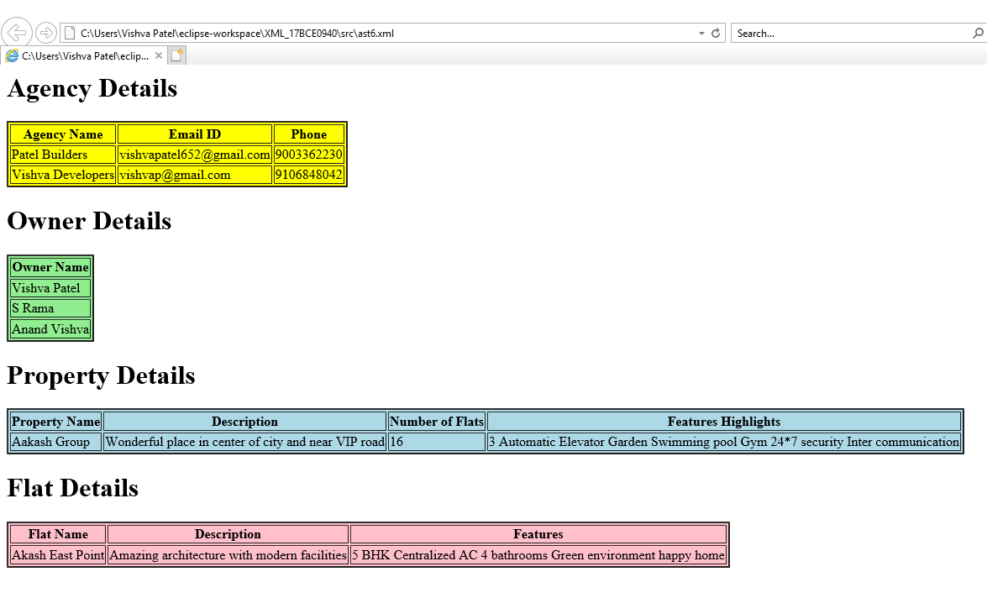

Well Formedness of ast6.xml

Well-formed xml file, tested using notepad++ plugin

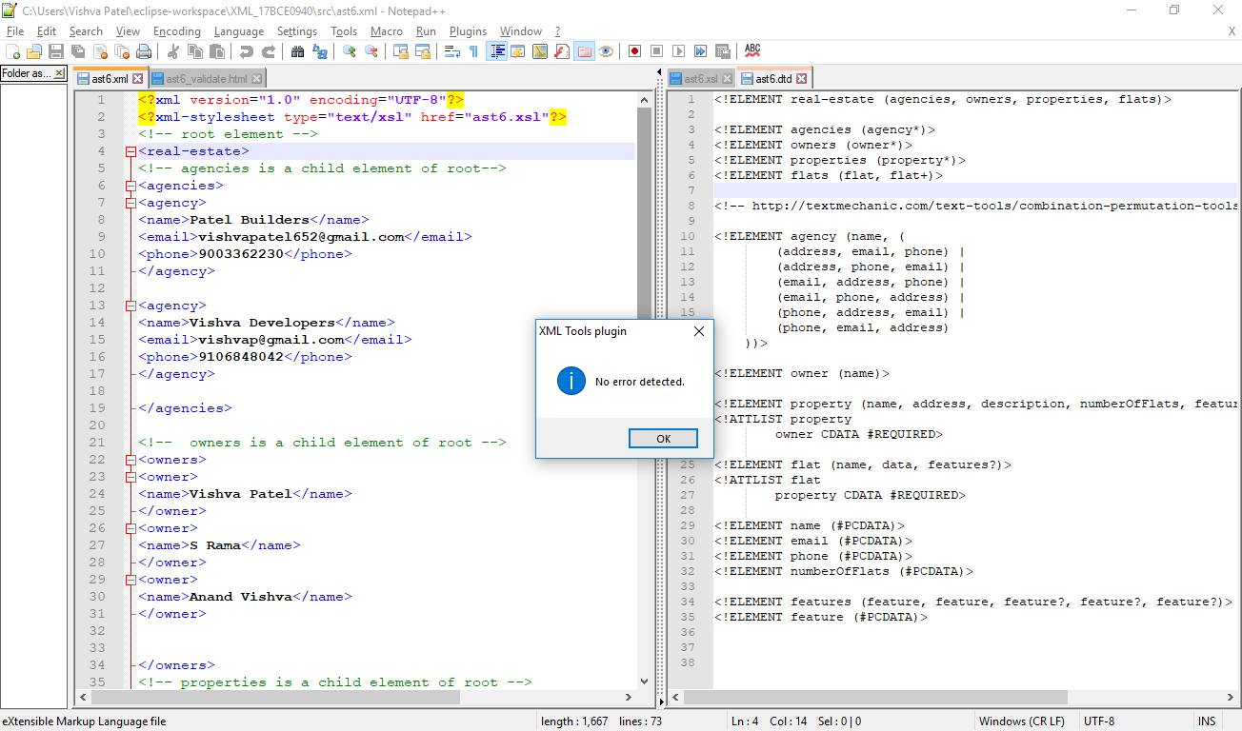

XML is well formed. (Validated using w3school’s online xml validator)

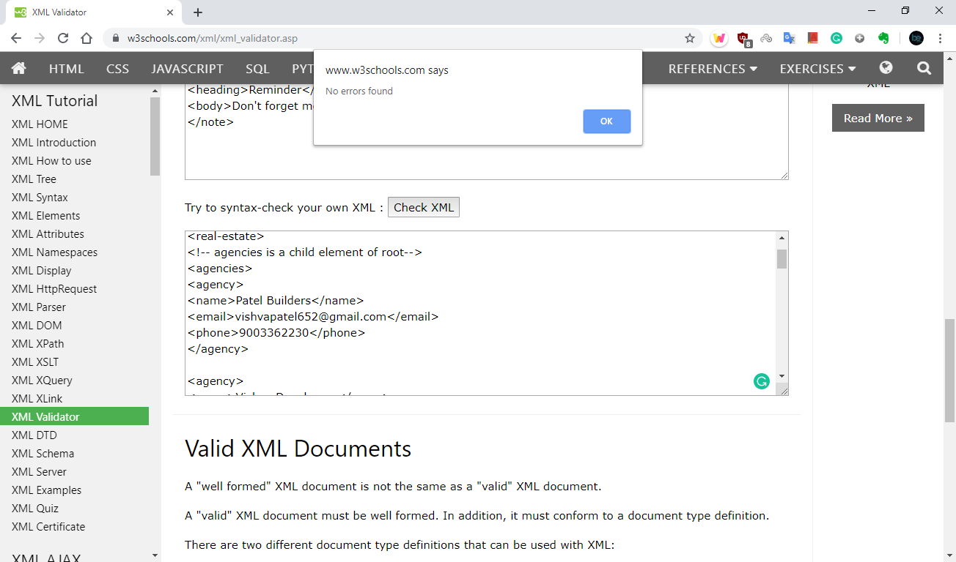

DTD Validation

Installing XML Tools plugin in notepad++

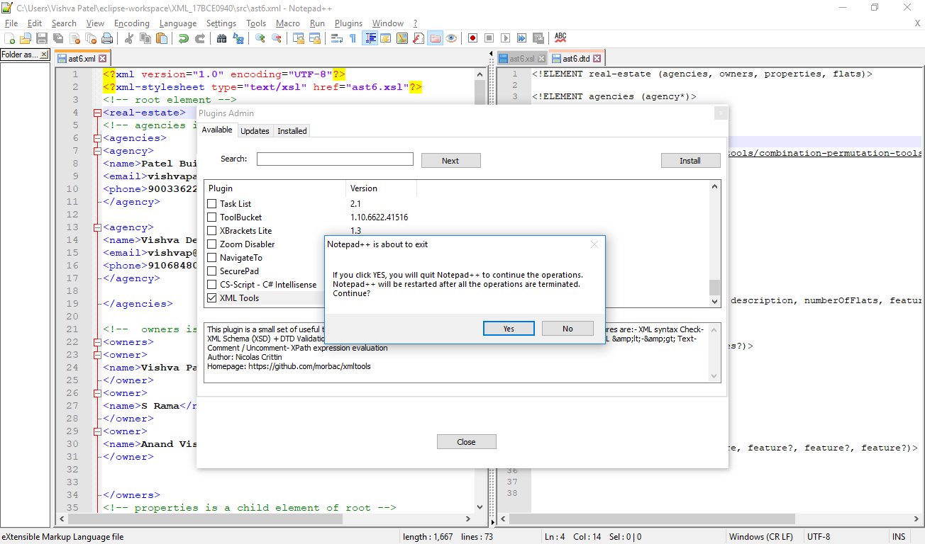

XML DTD Validation using notepad++ XML Tools Plugin

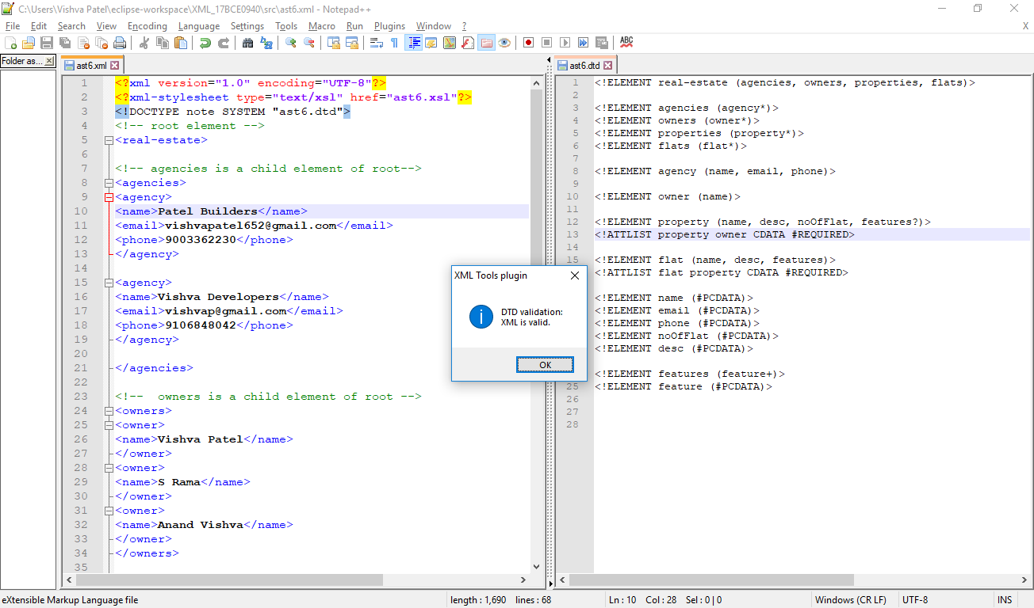

XML Schema Validation

Importing XSD file (ast6.xsd) for ast6.xml in Notepad++ XML Plugin

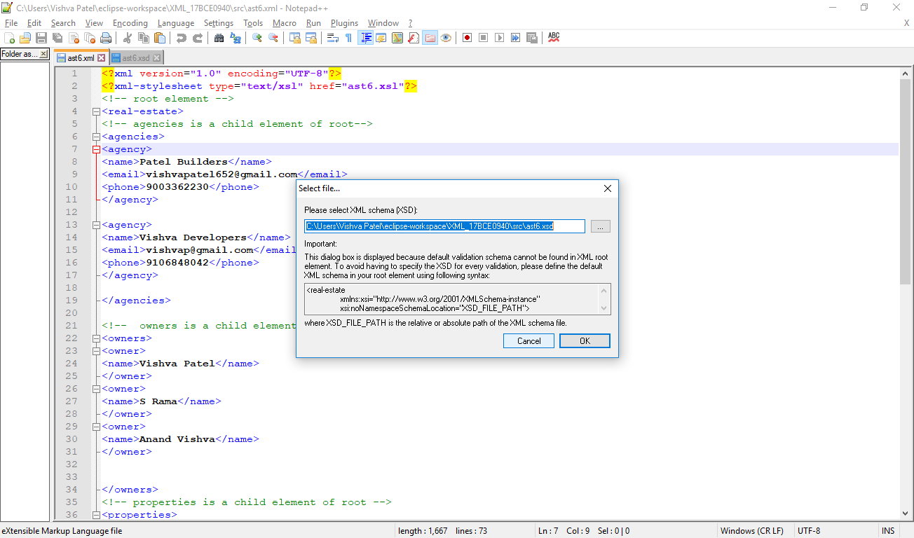

Ast6.xml is validated through XML Schema



